Tennistry — Your Tennis Life

1. Short Company / Product Introduction
Tennistry is a tennis community platform that helps players find compatible opponents, play competitive matches, improve their skills, and connect with local tennis communities.
Founded in the San Francisco Bay Area, Tennistry has grown to over 3,700 registered users and 1,700+ matches since February 2026.
Our platform offers three main features:
- Ranked & Casual Matches: Find local tennis players based on skill level, location, and availability. Play competitive ranked matches or casual games.
- Leagues & Ladders: Join local singles and doubles leagues, challenge higher-ranked players, and track your progress.
- Tournament Management: Tools for clubs and organizers to run round robins, playoffs, tournaments, and ladders.
Tennistry is available on iOS, with web-based tools for leagues and tournaments.

2. Challenge Goal / Desired Results
Our goal is to make tennis more accessible, social, and competitive by helping players spend less time searching for opponents and more time playing.
For Hackathon 2026, we want teams to explore creative ways to:
- Increase App Downloads: Attract new tennis players, especially in Northern California and Los Angeles.
- Improve User Activation: Encourage new users to complete their profiles, search for opponents, and play their first match.
- Grow Community Engagement: Increase participation in ranked matches, casual play, leagues, and ladders.
- Improve Brand Awareness: Help more tennis players discover Tennistry through creative content, social media, and community marketing.
Our ideal result: More qualified app downloads that turn into active players and real tennis matches, rather than just website visits or social media impressions.

3. Website
Tennistry Events & Leagues:
https://www.tennistry.net/event?tab=explore

4. Apple App Store
Download Tennistry:
https://apps.apple.com/us/app/tennistry-tennis-matches/id6757626581

5. Referral / Tracking Link
Hackathon 2026 App Store Campaign:
https://apps.apple.com/app/apple-store/id6757626581?pt=128440202&ct=Hackathon%202026&mt=8
Teams should use this tracking link when promoting the app so we can measure campaign performance.

6. Approved Marketing Materials
Teams may use the following Tennistry materials for their projects:
- Tennistry name, logo, and publicly available app screenshots.
- Publicly available website content, including event and league pages.
- Public Tennistry social media posts and promotional videos, subject to content and participant permissions.
- Product information and publicly available statistics provided by Tennistry.
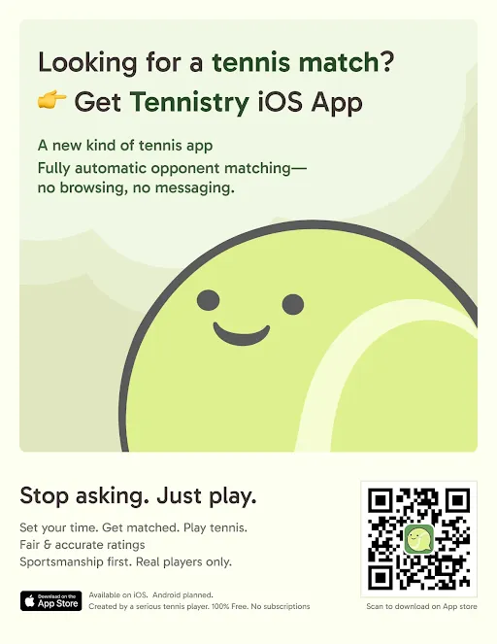
Teams are encouraged to create original marketing materials, including short-form videos, social media posts, graphics, and advertising concepts.
All marketing should accurately represent Tennistry's features and avoid making unsupported claims. Any materials intended for public release should be reviewed and approved by Tennistry first.

